The Oaks Community Primary School
Year 6 – Animals including humans

Key Knowledge
What is the job of the heart? | The heart is a hollow muscle. The job of the heart is to pump blood around the body.
Why is a healthy lifestyle important? | It is important to recognise the impact of diet, exercise, drugs and lifestyle on the way their bodies function.
Why is water important to keep us healthy? | Water plays a significant role in keeping us alive; especially in transporting blood and nutrients around the body.
Famous Scientists
William Harvey (1578 – 1657)
Discovered the circulatory system. http://www.bbc.co.uk/history/historicfigures/harvey_william.shtml

Key Vocabulary
Spelling | Meaning
Circulatory system  Diet  Drugs  Shadow | heart, blood, veins, arteries, pulse, clotting  balanced, vitamins, minerals, proteins, carbohydrates, sugars, fats  caffeine, nicotine and alcohol
Reflect | Bounce,mirror, reflection
See | light source
Diagrams and Symbols
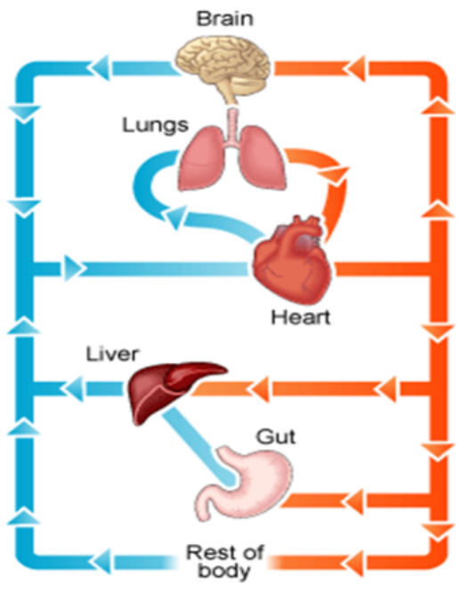 | 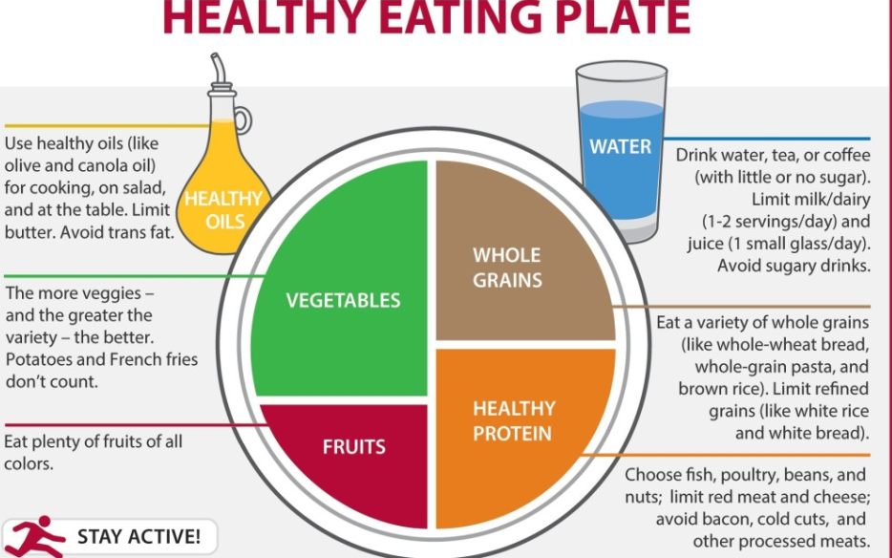

Key Questions
- Can I Identify and name the main parts of the human circulatory system, and explain the functions of the heart, blood vessels and blood?
- Can I recognise the impact of diet, exercise, drugs and lifestyle on the way my body functions?
- Can I describe the ways in which nutrients and water are transported within animals, including humans?

