The Oaks Community Primary School
Year 4 - Sound
Diagrams and Symbols
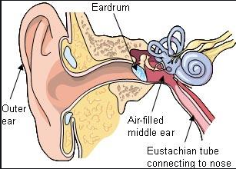

Key Vocabulary
Ways to create sound – bang, blow, shake, and pluck
Loudness – quiet, quieter, quietest, loud, louder and loudest
Pitch - low, lower, lowest, high, higher, and highest

Key Knowledge
What is a sound? | Sound is a form of energy.  Sounds are made when objects vibrate.
What is a loud sound? | The larger the vibration the greater the pressure change, the larger the amplitude, the louder the sound.
What is pitch? | Pitch refers to how high or low a sound is. The pitch of the sound is due to the frequency of the vibration.
Key Questions
What is a sound?
What happens to the sound of the drum when we get further away from it?
Where does sound go when it has been made?
How can we alter the loudness of a sound?
How do we change the pitch of a sound?
Explore
Famous Scientists
Ernst Mach (1838-1916) | Described how shock waves are formed.
Heinrich Hertz (1857-94). | The unit of frequency used for all kinds of waves and vibrations is named after him. One Hertz is equal to one vibration per second.
Robert Boyle (1627- 1691) | He discovered Boyle's Law – the first of the gas laws – relating the pressure of a gas to its volume; he established that electrical forces are transmitted through a vacuum, but sound is not.

